**\*Please make a copy of this document and include this in your GitHub repository for your submission, using the tag #AndroidDevChallenge\***

**Tell us what your idea is.**

*The omnipresence of technology in the form of smartphones, tablets, and cameras have led researchers to constant improvement in the quality of photos. But most of the photos are not as crisp and sharp when shot in low light due to less photon count and short exposure. In my project, I have developed a model using Convolutional Neural Network with TensorFlow library on my own dataset of RAW short aperture images and its corresponding high aperture images shot on mobile phone cameras. We later deployed a basic android camera application that takes a low illumination RAW capture and processes it to provide an image that is perceptually good. According to the current architecture, the actually processing is still happening on the computer, we have an android application which takes a RAW capture, sends it to the computer, computer processes it and then sends a .png back to the application. I want to make an application which can process the raw image on the phone itself and give us the corresponding output. This is not a phone dependent application, any mobile phone can use it that has the capability of capturing RAW images.*

**Tell us how you plan on bringing it to life.**

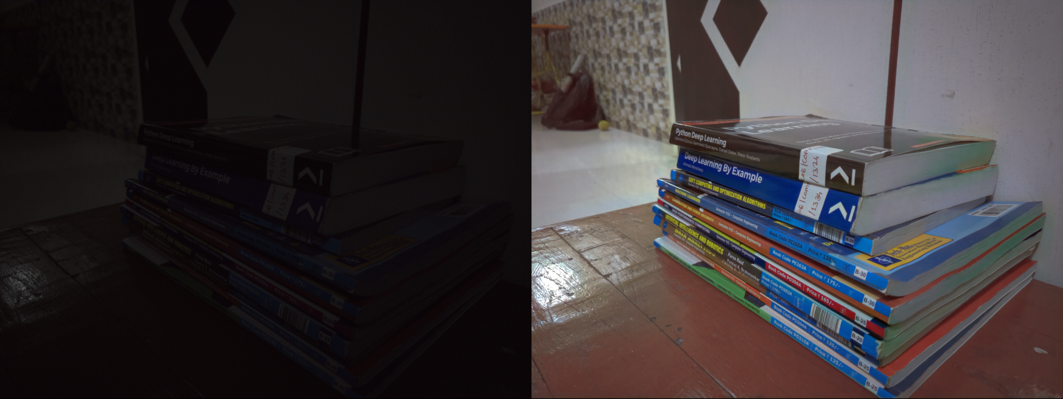

*[Above photo is the current output(right) we are getting for the input(left).]*

*I’m trying to create an application that can see in the dark. I’m trying to achieve this using fully Convoluted Neural Network. I have created the model for prediction using a dataset of low aperture RAW images and its corresponding high aperture RAW images shot on mobile phones. This was my undergrad research, you can find my paper on the same at -* [*https://www.ijeat.org/wp-content/uploads/papers/v9i1/A9557109119.pdf*](https://www.ijeat.org/wp-content/uploads/papers/v9i1/A9557109119.pdf)

*My team also published a comparative survey - (*[*http://www.ijircce.com/upload/2018/november/29_A%20Comparative.pdf*](http://www.ijircce.com/upload/2018/november/29_A%20Comparative.pdf)*)*

*where we have compared the various low light imaging techniques and how this methods stands out of the box as it uses a data driven approach. With the help of google and proper mentorship, I’m pretty sure we can improve the quality which we are getting right now and also try to process the image (pass it to the network) on the phone itself. All the details regarding how we were able to achieve it are described in the papers. Please feel free to contact me for any further ellaboration.*

**Tell us about you.**

Hi I’m Abhishek. I graduated from Savitribai Phule Pune University this year, and I’m currently working at Teachers Insurance and Annuity Association (TIAA GBS) as a Software Developer. I’m interested in Computer Vision and Artificial Intelligence. I’ve previously worked for Persistent Systems, where I was a Machine Learning Intern. I intend to pursue a PhD in Computer Science and work at a research lab at an industry or a university, where I wish to solve modern world problems with the help of AI.